Digital Microscope（KH-7700）

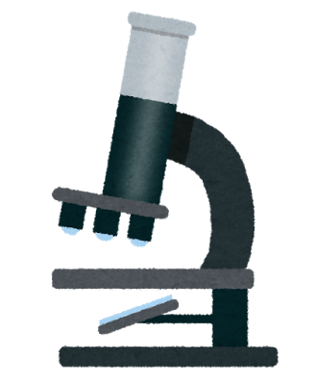

Digital Microscope

Simple Manual

The name of each part

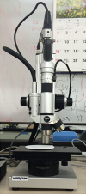

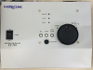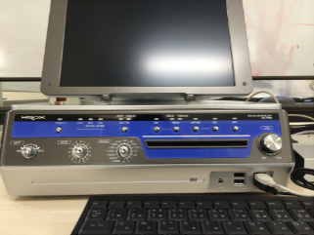

　　　　　　　　PC　　　　　Z-axis controller　　　main part

Written by A.Miyake (original ver. 2017.3.8）

M.Ishikawa (Eng. ver. 2017.10.16)

Startup and Initialize

1. Turn on the power switch of Z-axis controller. Then “LOCAL” lamp is on and “DATA line” lamp brinks.

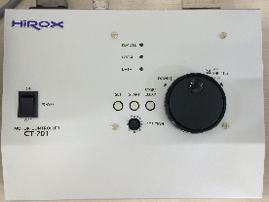

CAUTION: If you start the PC before starting the Z axis controller, the PC cannot control Z-axis controller. So, please keep the starting order. When mistake the order of starting up, once turn off the powers of PC and Z-axis controller and reboot with right order.

1. Press power button on PC. Then POWER LED is on.

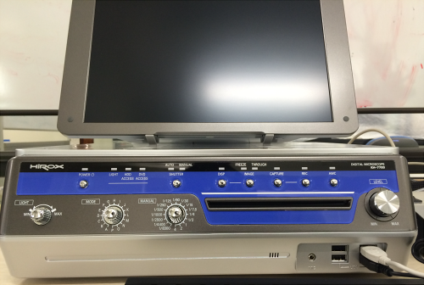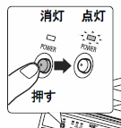

1. Select your language by the popup window. Please keep the check on. If the system boots with Japanese and skip automatically this selection, please call the stuff.

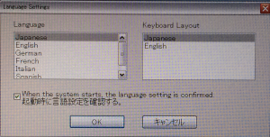

4. “Lens/adapter settings” window automatically open. Please confirm the information about the lens model and current objective lens as follows.

lens 「MXG-2500REZ」

adapter Current objective lens

Low-Range／Mid-Range／High-Range

　　　　☑　起動時にレンズ設定を確認する。　←checking

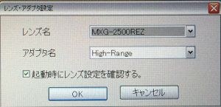

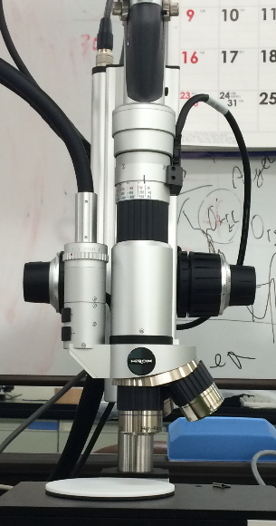

1. Select “MAX” by LIGHT knob, “C” by MODE knob and “AUTO” by SUTTER button on front panel of PC.

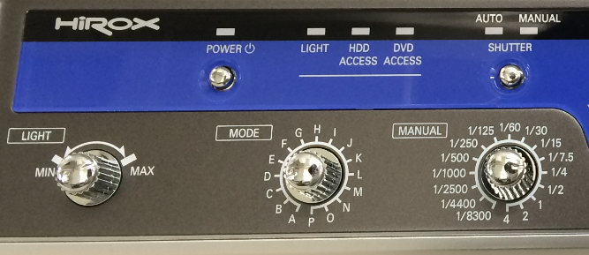

White balance correction (AWC)

1. Set the white board on the stage.

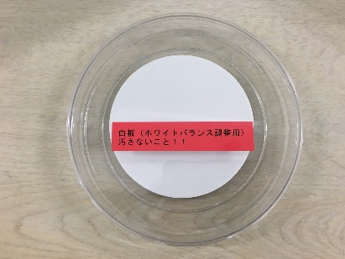

CAUTION: Be careful not to contaminate the whiteboard。

2. Focus roughly on the white board using course dial (inner) and fine dial (outer)。

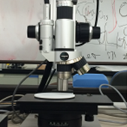

Course dial

Fine dial

3. Press “AWC” button on PC panel to start the correction. In the correction process, the LED is blinking. The process will be finished within several seconds and the LED is off.

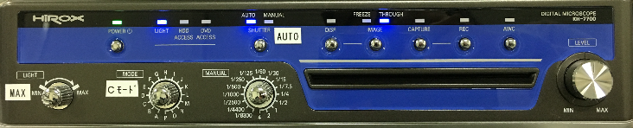

Caution: Other operations disturb the correction. So, leave as it is until the process is finished.

4. Put the white board back where it belongs.

Preparation for observation

1. Set your sample on the stage.
2. If the scale bar is not shown in lower right part of the screen, select “Displays scale” If you want more other information on screen, you also select by same way.

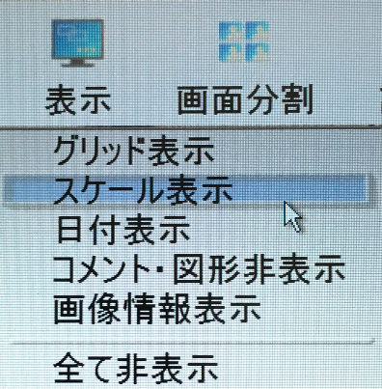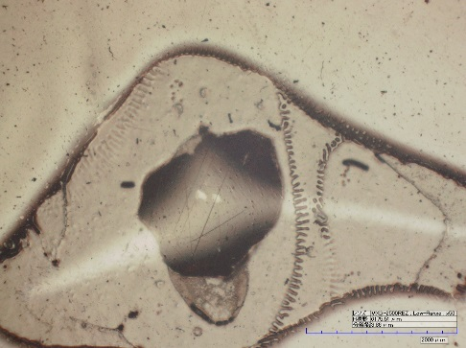

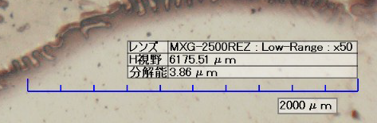

　　　　　　　　　　　　　　　　　　　　　　　　　右下のスケール表示

1. When you switch the objective lens, please confirm the refresh of the lens information in the lower right part of the screen and side blue LED right is ON. If not The position of objective lens is wrong..
2. Focus on the sample.

CAUTION: Be careful not to hit the sample by the objective lens.

Manual control of the focus (Strongly recommend)

Use course dial (inner) and fine dial (outer) on the side of the objective lens.



Course dial

Fine dial

Z-axis controller or the control panel on the screen (not recommend)

① Select the “Focus control” 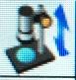 in tool bar.

You can control the position of the objective lens by following ways.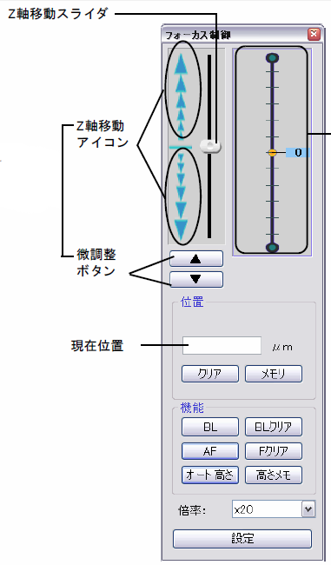

* Z axis controller
* Z axis slider, icons, Fine control button on PC
* Scroll wheel of the mouse

②　You go down the objective lens by any way and press the “BL” button in the tool box to memory the software bottom limit of the position of the objective lens. This “BL” function is only for the software control.

③　Control the objective lens and focus on the sample

1. Turn the zoom ring to select the magnification. The magnification is selected by the matching of upper black line and the scales of “w, 1, 2, 3, 4, 5”. Please stop the zoom ring at the clicking point and confirm the side blue LED is on. If not, the position of the zoom lens is wrong.

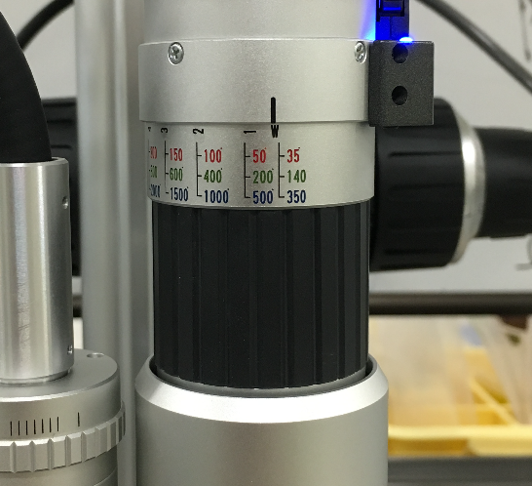

**ズームリング**

1. Turn the ring of light source to arrange the brightness of the illuination.

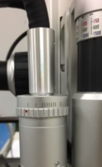

7. Turn the “LEVEL” knob on PC panel to control the brightness of the lighting.



8. The colors and contrast of screen can be controlled from “Camera Menu”  in tool box.

Observation

****Typical methods (in tool bar)

　　　2D measurement: The distance between two points.

Height measurement: This function can be used in 3D measurement

　　　3D measurement: cross section and height

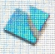　　　2D tiling: get the image from wider area

You want other methods or procedure; please refer “Manual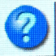” in tool bar. The center staff also helps you for finding the best way.

Save images

1. Press the “DISPLAY” button on the front panel of PC to select whether the scale bar and other information will be included in the image to be saved or not.



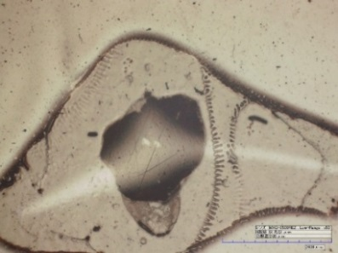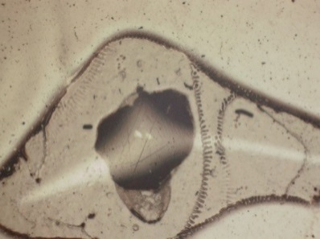

　　with information　　 no information

1. If you want to inset the any texts or graphics into image to be saved, use the “Comment” 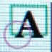 in the tool bar.

3. Select the “Capturing as …” in RECORD menu to save the image. The save dialog window opens. You select your working folder and set header of filename.

If you set the information about working folder. You can also use more simple way as follows. This way is easy however you must recovery the setting about working folder after finishing because your working folder is saved as the current working folder for even other users. If not recover, data may be added your folder by other users who use the same function without setting for his working folder.

① Select ”Capture setting” in “RECORD” menu and set your working folder and header of filename.

② Press the “CAPTUE” button on the front panel of PC to capture the image.



Your saved images can be checked by “LIBRALY“ menu.

Write the saved images in the CD-R

1. Enter a blank CD-R disk into the drive on the front panel of PC.

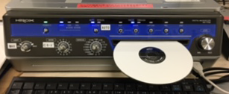

1. Click the “Library” in the tool bar. Select your working folder in left column.
2. Click “CD/DVD” icon to boot a wiring software.

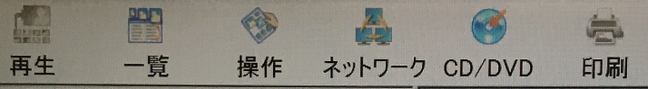

1. Drag the image files to be write from the library and drop them on the right area of the opened dialog.

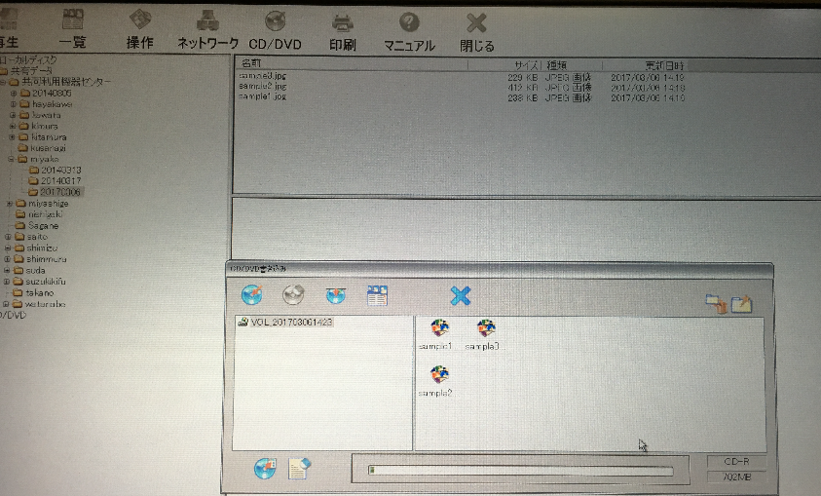

1. Click “Writing” button in writing window to start writing.

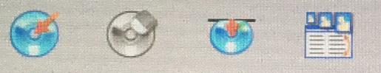

1. After the writing, the CD-R is automatically ejected.

Finish

1. Click “SHUTDOWN” button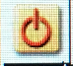 to shut down the PC.
2. Turn off the power switch of Z-axis controller

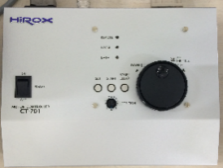

1. Set the lowest magnification (W position) by turning the zoom ring.

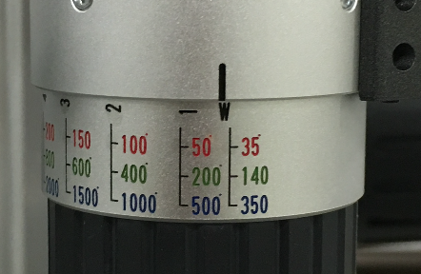

1. Put the cover.

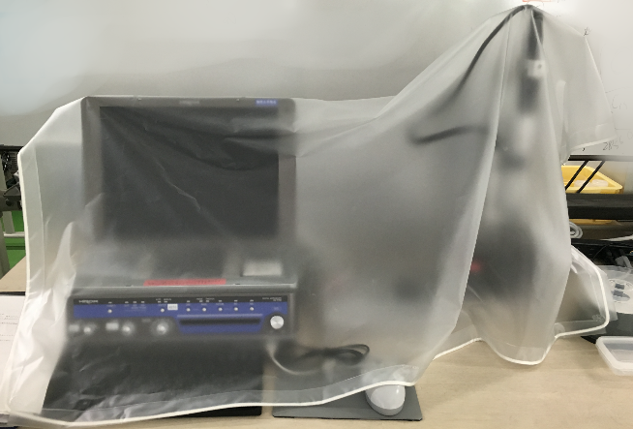

5. Fill in the log book.