ESCA3400 Instant Manual (English Ver. 1.00)
2017.8.1
* * * CAUTION * * *
・High pressure of the chamber gives you only bad data and shorten the lifetime of the instrument. So, please watch for the pumping with a generous feeling!
・Even if a problem is not serious, please report it to the person in charge when you find.
・Please check the status of the processing by pointing and calling check of the monitor and lamps of front panel.

1. Check the initial conditions

・MAINS button on the front panel is turned on.
When the conditions are not as follows, don’t use and contact the operator.
・Vacuum pumps works
・Ion gauge works and the pressure is shown on front panel.
・The lump of GATE VALVE CLOSE is on.
・The lump of LOAD PUMP is on.

2. Start up

2-1. The power button on the monitor of PC is turned on.
2-2. The power button of PC is turned on.
2-3. Log-on-ID and password are “kratos”.
2-4. Double crick the icon ”Vision Manager” on desktop. (You must turn on the MAINS switch in advance of this process.)
2-5. Then, Vision Manager communicates with the ESCA. This process uses 2~3 minutes. When the process is finished, the process monitor window is closed automatically.
2-6. Select MANUAL WINDOW in WINDOW menu. Select ”Instrument Manual Control”.
2-7. Check that the indicators on Instrumental Manual control are green as below.
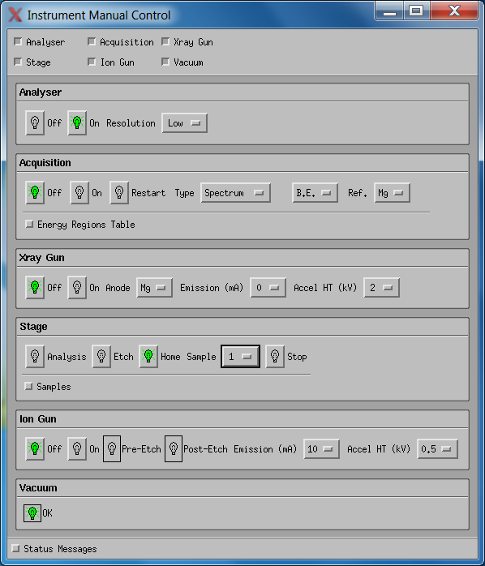
3. Sample preparation

3-1. Attach your sample on the head of the sample holder using carbon tape. The height must be kept with the same level of the center part of the sample case as below.
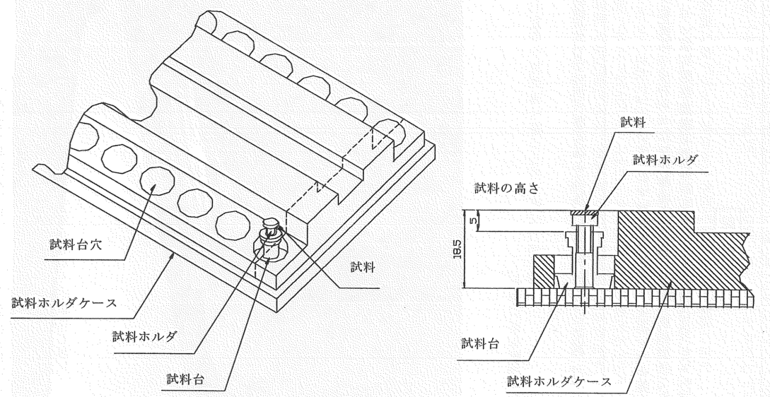

3-2. Set the outer ring. Be careful of the upper and bottom of the ring. The ring has the slit at the inner face of bottom part. Make sure the ring is securely attached.
* * * CAUTION * * *
The space for analysis is very small. So, do not fix the sample such that the sample protrudes from the upper surface or the ring. When user fix the large sample, the specimen is caught in the device and repairing the maker becomes necessary.

4. Introduction of the sample

* * * CAUTION * * *
Please take enough time for evaluation. Even if you harry, you cannot obtain good data and it will lead to instrument failure.

4-1. Short press the LOAD: LEAK button to stop the pumping of introduction chamber. (The pumping is stop.)
4-2. Then, long press the LOAD: LEAK button until the Introduction port opens. (N2 gas flows into introduction chamber while pushing the button.)
4-3. Pull out the fork.
4-4. Hock the sample on the fork. At this time, confirm the sample is not tilted. Below image is bad setting because the sample holder is tilted.
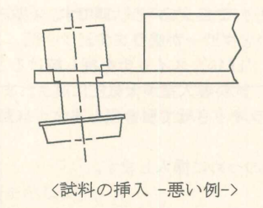
4-5. Push the fork softly. Press the LOAD: PUMP button.
4-6. Wait for 10~15 minutes after <1Pa lump turns on. 10 min is for the film or solid sample. When your sample is powdery, wait 15 min or more.

5. Introduction of the sample

* * * CAUTION * * *
THIS PROCESS HAVE CAUSED TOO MUCH PROBREMS. ONCE PROBLEM IS CAUSED, TOO LONG TIMES AND TOO MUCH COST WILL BE NEEDED. SO PLEASE BE WITH THE GREATEST CAUTIONS!!

5-1. The illumination switch for main chamber is on.
5-2. Look through the viewing port and check that no sample is in the hole in front.
5-3. Confirm that the same sample position is selected by checking the display and front panel.
5-4. Confirm that the “HOME” position is selected by checking the display and front panel.
5-5. Press the GATE OPEN button and check the lamp on the button is turned on.
5-6. Release the lock of the black knob. At this time, the alarm is on.
5-7. Push the transfer rod slowly until it hits the end with watching the motion of the sample.
5-8. Press the ETCING button in the manual control panel on the monitor. The sample rod push up the sample holder. Confirm that the sample holder is lifted from the fork.
5-9. Pull the knob of the transfer rod and fix it.
5-10. Press the GATE CLOSE button. Then the pressure of the main chamber gradually goes down.

When you have some samples, follows below procedures.

5-11. Press the Home position button in the manual control panel on the monitor.
5-12. Select the next sample number.
5-13. Repeat the processes of 4 and 5.
5-14. Wait until the pressure reach 3 x 10⁻⁶ Pa or less.

6. Parameter setting

The details of parameter setting is describe at the end of this manual.

7. Aging of the X-ray gun: degas

7-1. Check the pressure. If the pressure is higher than 3x10⁻⁶ Pa, wait for the pumping.
7-2. X-ray gun is turned on after confirming that the Emission is zero and Acel HT is 2kV on Manual Control panel.
7-3. 4 kV is set on Accel HT. Once the pressure become higher. Wait for the recovery of the pressure. If the X-ray gun is shut down, please stop the aging process immediately and wat for the recovery of the pressure.
7-4. Set 10 kV on Accel HT after the pressure reach 3 x 10⁻⁶ Pa or less. (Cannot set 12 kV!)
7-5. 5 mA is set on Eission. Once the pressure become higher. Wait until the recovery of the pressure and the pressure reach 3 x 10⁻⁶ Pa or less.
7-6. 10 mA is set on Eission. Once the pressure become higher. Wait until the recovery of the pressure and the pressure reach 3 x 10⁻⁶ Pa or less.
7-7. 15 mA is set on Eission. Once the pressure become higher.
7-8. X-ray gun is turned off after the pressure reach 3 x 10⁻⁶ Pa or less.

8. Measurement

8-1. Check visually the sample table and sample from the peep window to see if there is any abnormality. ,
8-2. Confirm that the displayed pressure is 3 x 10 - 6 Pa or less. Do not start measurement at higher pressure than this standard.
8-3. Select the entire measurement procedure and start measurement with the Submit button.
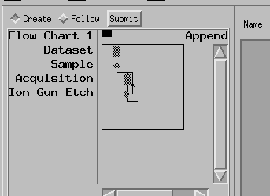

When the measurement starts,
・ANALYSIS lamp on the front panel turns on.
・X-ray lamp under the introduction port turns on.
・If you press “Follow” button as shown below the procedure you are working on will be displayed in red.

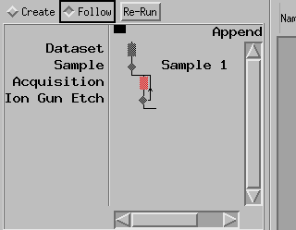

When you want to stop, press “Stop Run” and you can press “Re-start” to restart after changing parameters.

9-1. Select the number of sample to be retrieved on the manual control menu.
9. Take out the sample

9-2. Press the GATE OPEN button and check the lamp on the button is turned on.
9-3. Release the lock of the black knob.
9-4. Push the transfer rod slowly until it hits the end wall with watching the motion of the sample.
9-5. Press the HOME position button in the manual control panel on the monitor. The sample rod goes down and the sample holder is passed to the fork.
9-6. Pull the knob of the transfer rod to its end and fix it.
9-7. Press the GATE CLOSE button.

If you want to retrieve another sample, follows below procedures.

9-8. Wait for 10 minutes or more to evacuate the introduction chamber.
9-9. Repeat the processes of this chapter..

10-1. Save the data file as *.dset files. The system can save row file only. The processed data cannot be saved.
10. Save data

11. Finish

11-1. The programs of Vision Processing and Vision Control are finished. In this process, please select “NO” when the Vision Control asks “Config Save?”.
11-2. Shut down the Windows.
11-3. Turn off the power switch of the monitor.
11-4. MAINS button on the front panel is turned off.

6. Setting for save file

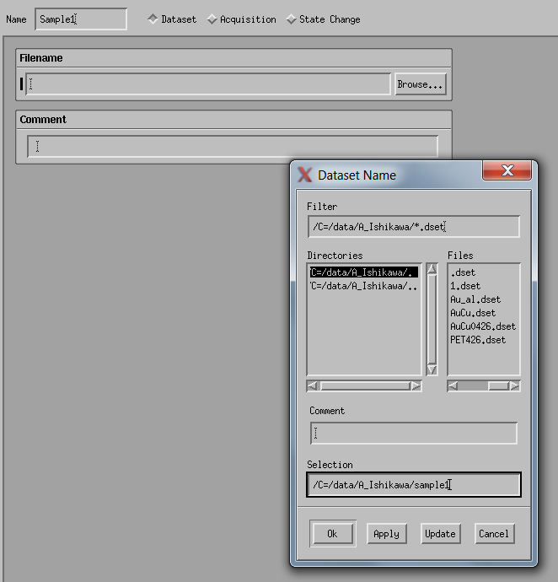
Select “Dataset”. Press “Brows”button. select your folder by Directories. Add your file name after the text. Data save folder is located at C=/data/ your lab/ …
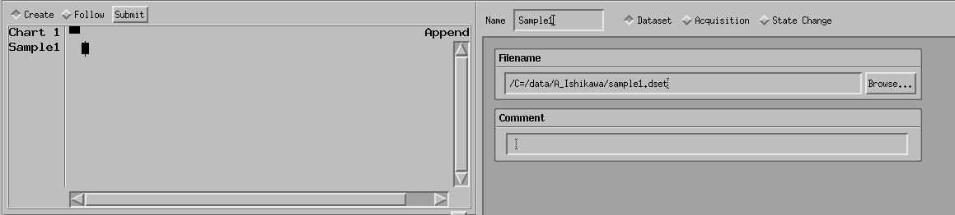
Click the center button to insert your procedure into the task tree.
6-2. Select target sample No.
Select “Stage Change” and “Psitions”
Click the center button to insert your procedure into the task tree.

6-3. measurement rapameters
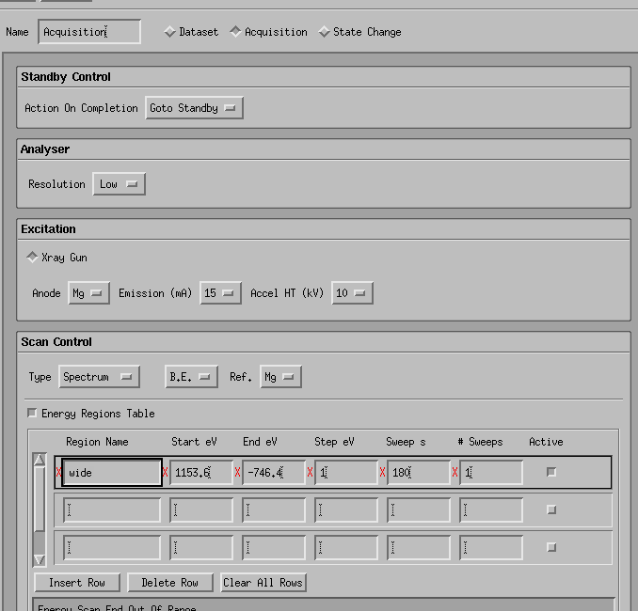
Press “Acquisition” to open the parameter window. Enter the region name ( such as wide, C 1s, Au 4f). Pressing the enter, the preset parameter is filled in. “x” symbol in above image means wrong parameter.
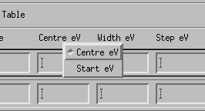
At the beginning, the parameter must be set by the Center and Width. You can also use start-end by clicking right button on the “center eV” label.
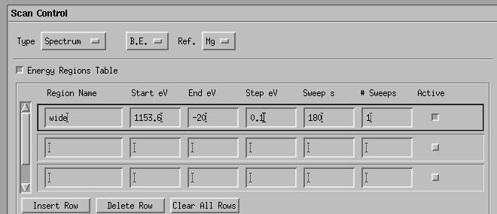Correct Wide parameter. Dwell ms means the time for one point. The time is determined so that one measurement is one minute. Right click on the Dwell, you can select the “Sweep s (means total time for one san).

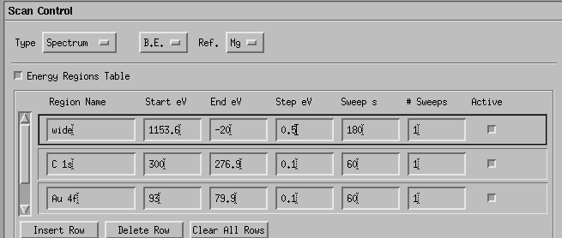
Entering C 1s or Au 4f in the region name, the space is needed between element name and orbit name. When you enter the region without space such as C1s or Au4f, the preset parameter is not set. At that time, once you must delete the row by “Delete Row” and re-enter the right region name.
Click the center button to insert your procedure into the task tree.

6-4. Etching parameter
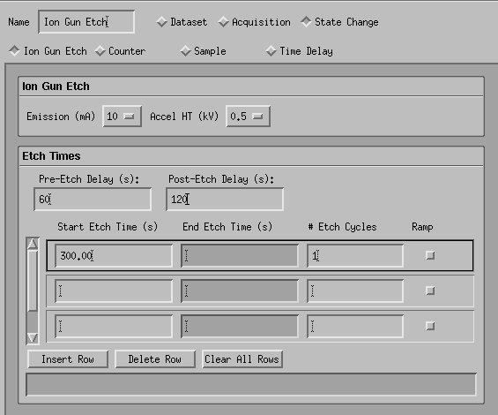
To open the parameter window for etching, press the Ion Gun Etchin” in “Stage Change” and set each parameters.
Emission and Accel HT(kV) determin the intensity and energy of ions. The biggier value, the stronger etching occurs. At the first try, it is good to start 10mA, 0.5kV.

Click the center button to insert your procedure into the task tree.
6-5．loop
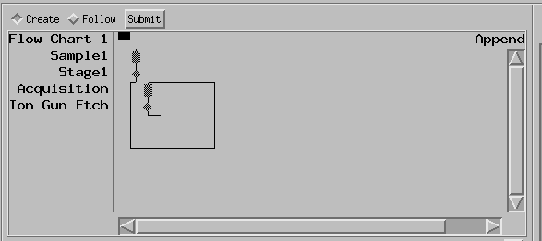
Select the area where you want to loop.

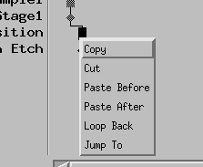
Right click and select “Loop Back”.

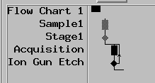
After the setting, the chart is changed as above. The number of loops is determined by the number of #cycle in etching parameter.

6-6．Save runspec
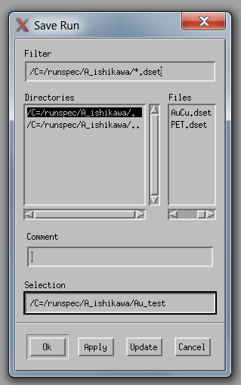
After making the procedure tree, you should save the runspec (means the procedure tree) by selecting “Save Run” in File menu. The location for save is “C=/runspec/ your lab/…”.

