**Simple Manual for conventional SEM**

HITACHI S-3000N Scanning Electron Microscope(SEM)

22/Jun./2017 Hisashi Hirata

31/May/2018 Toshihiro Hayakawa

**Start up analyzer**

1. Power activation
2. Switch on “EVAC POWER ①”.

(Alarming “Pee” will be lost about 3 minutes later)

R.P.(Rotary Pump) start up automatically and “LOW” lump and “WAIT“ lump light up at exhaust system panel.

(2) Switch on DISPLAY②.



1. After computer automatically stand up, enter password ”S-3000N” and log in.

Application automatically stand up. ※「S and N are capitals」

1. As below picture, wait that vacuum bar change “red(low vacuum)”→”green(medium vacuum)”→”blue(high vacuum)”.After change blue, wait for 3 minutes additionally.

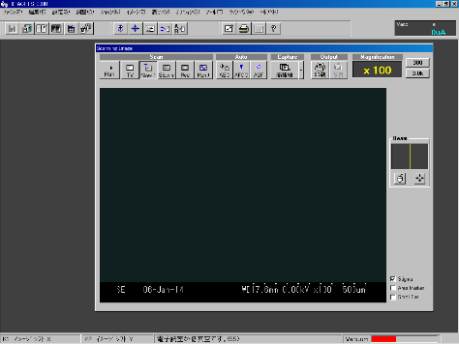

(use sand clock)

※About exhaust air (Vacuum)：D.P.(Diffusion Pomp ) heat up for about 25 minutes.

Wait for “High “lump light up.



**Start up electron beam**



1. Click left side of mouse on　　　　　　　　 and set conditions of electron beam as below.

Set accelerating voltage：Vacc(kV) you need.

(**Metal: about 15~20kV , Other: under 7kV ) ※MAX is 30kV**

　　　Indication of Accelerate voltage

　　　　　Metal　 ：15~20kV(25kV is OK at high magnification)

　　　　　Polymer ：5～10kV

※Under 5kV, check for低加速電圧バイアス(bias for low accelerate voltage)

AFS(Auto Filament Saturation)：　**中(Normal mode)**

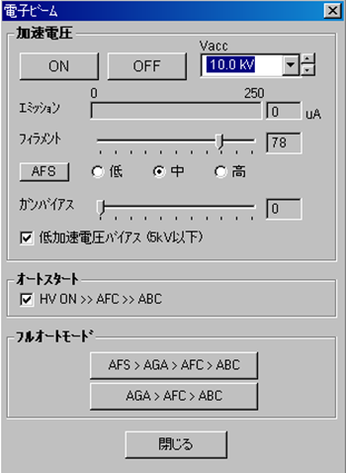　　　　　オートスタート(Auto start)　：　Check

1. After setting, close window.
2. Rotate [Focus] tab, and regulate **WD (Working Distance)** to about 15mm.

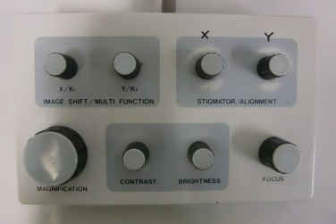

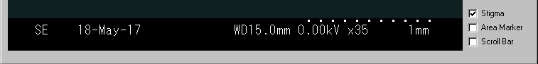

If you observe high magnification, set WD to 10mm.

1. Rotate [MAGNIFICATION] tab and regulate magnification to minimum.

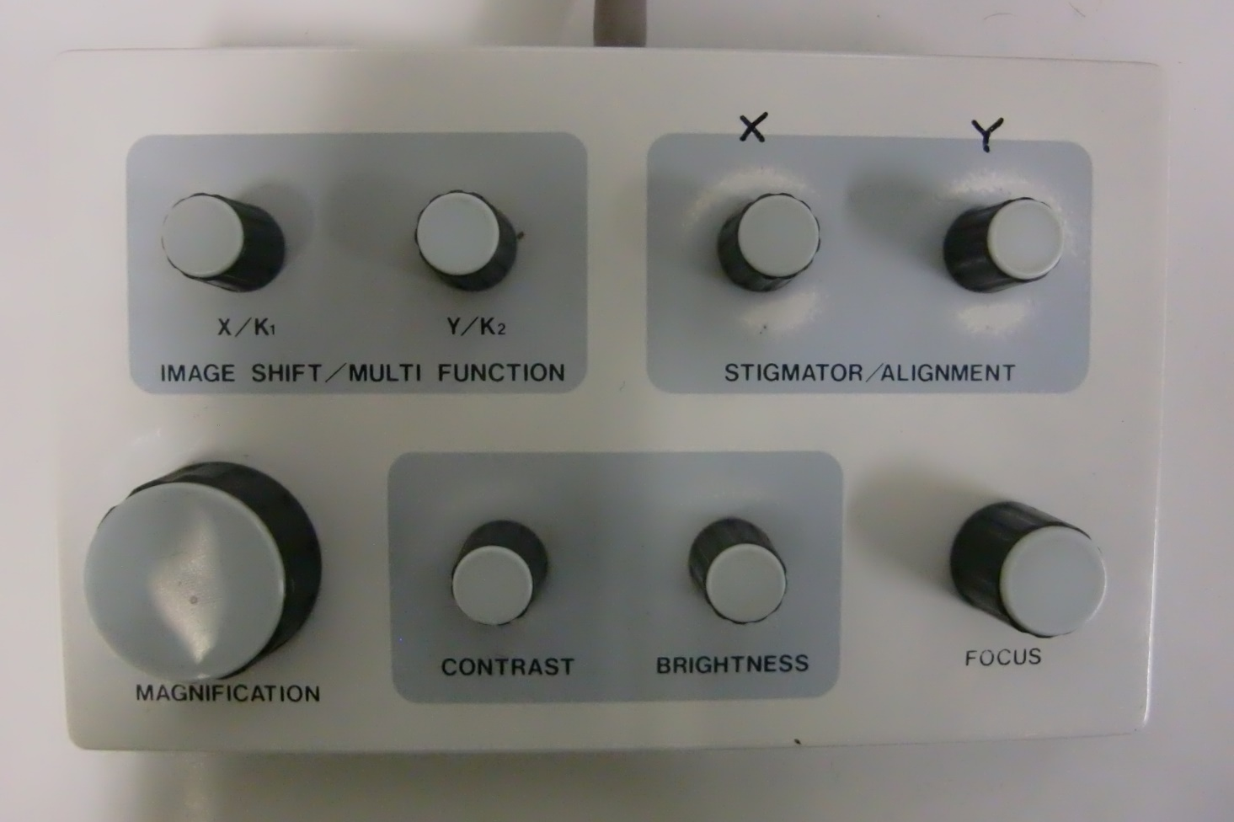



1. Click　　　　　　 and start up electron beam.

**Insert sample**



1. Make sure that accelerate voltage is OFF. (Vacc is 0.00kV　　　　　　　　　)

If electron beam is ON, click , and turn off electron beam.

**For protection electron gun, wait for 3minutes until electron gun become cold. (use sand clock)**

1. Make sure that sample stage locates exchange position.

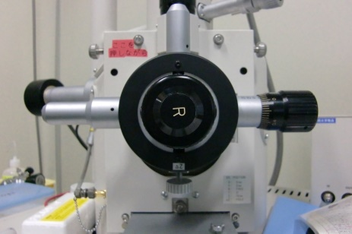X=0 mm T=0°

Y=0 mm R=Option

Z=15 mm

3.Rotate [MAGNIFICATION] tab and regulate magnification to minimum.

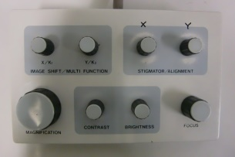

4.Push AIR/EVAC button. LOW lump light up and become atmosphere pressure in the analyzer (for about 1 minutes). Pull sample stage slowly. **(Wear the latex glove.)**



5.Remove blank sample on the sample stage with rotating 「R」tab to right and set your sample.

For anti-drop, Rotate 「R」tab to left when you set sample.

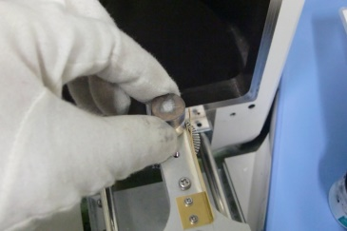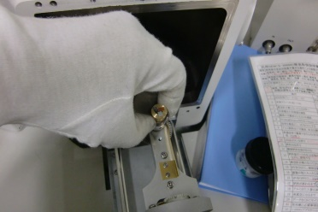

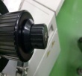

「R」tab

1. After close sample stage slowly, push AIR/EVAC button with holding lightly against upper left of door and vacuate in the analyzer.

※Hold lightly against upper left of door until pump sound become small.

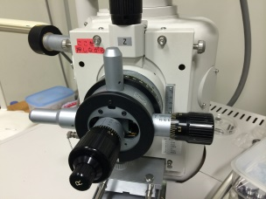

1. As below picture, wait that vacuum bar change “red(low vacuum)”→”green(medium vacuum)”→”blue(high vacuum)”.After change blue, wait for 3 minutes additionally.

(use sand clock)



※If vacuum bar remain red, hold against door or push **AIR/EVAC** button and stop exhaust air.

Try above 「6.」 again

**Obsevertion**

1. Make sure accelerate voltage and start up electron beam.

(refer to　**Start up electron beam**, page 3,4)

※If you change accelerate voltage, you must execute AFS or AFS>AGA>AFC>ABC.

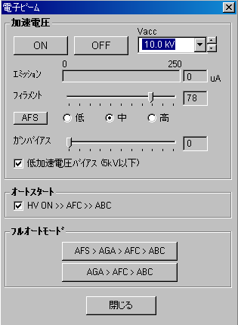

1. Select TV1orTV2(scan mode) (TV1 and TV2 switch by click)



1. Click ABC(Auto Brightness Contrast) for regulation of brightness automatically.

And fine-tune by rotating **BRIGHTNESS and CONTRAST tab**.





1. At first, focus from low magnification because electron beam cause damage to sample.

So, shift to outside you want to observe by rotating “X-axis, Y-axis” tab, and regulate focus.



**■Regulate focus**

Click AFCC(Auto Focus ) and focus automatically. And fine-tune by rotating [Focus] tab.

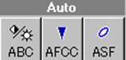

1. Set higher magnification than you want to observe, and regulate astigmatism.

**■Regulate astigmatism** ［Execute when you change height and accelerate voltage.］

(1) Click ASF (Auto Stigma Focus) and regulate astigmatism automatically.



If astigmatism didn’t fit automatically, select Red M.

(Red F, Red M and Red S switch by click)



1. Regulate astigmatism to become cloudy equally up and down

by rotating **STIGMATOR/ALIGNMENT tab.**

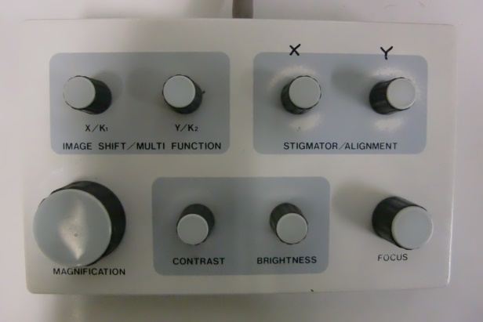

※After above, you would not better click [AFCC]

　　　　　　　　　　　　　　　　　　　　　　※After setting [STIGMATOR/ALIGNMENT],

regulate only by rotating [FOCUS] tab.

(3) Select TV1 or TV2 (scan mode). (TV1 and TV2 switch by click)



1. After regulating astigmatism, lower magnification and shift image you want to observe by rotating “X, Y ,T, R-tab”.

Use **IMAGE SHIFT X、Y tab** when you observe at high magnification(over thousands).



1. Select Slow (scan mode).(Slow f or Slow s)

(Slow f switch to Slow1 and Slow2, Slow s switch to Slow3 and Slow4 by click.)



**Save images**

1. Click ”高精細”(capture).



1. Click and select image you want to save. Click **セーブ(save)**.

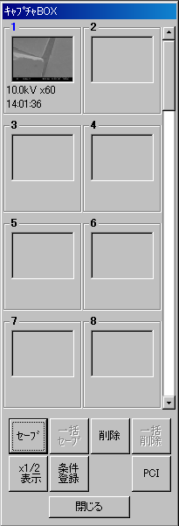

※Save location is User folder at D drive (there’re at desktop )

If there’re not your file ,click新規フォルダ(new file)

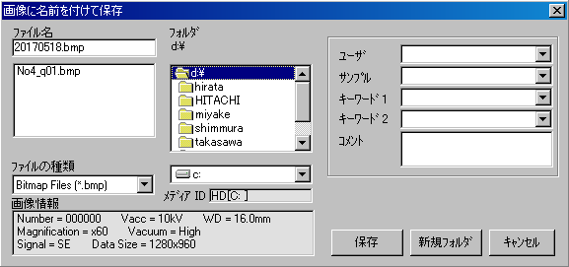

File name

new folder

1. Take date from PC by CD-R. (Don’t use USB)
2. Open DVD drive and set blank CD-R.



1. After CD-R’s folder open automatically, copy and paste you made file at below step “2”.

(Paste your file to (a) and click (b)”これらのファイルをCDに書き込む“)

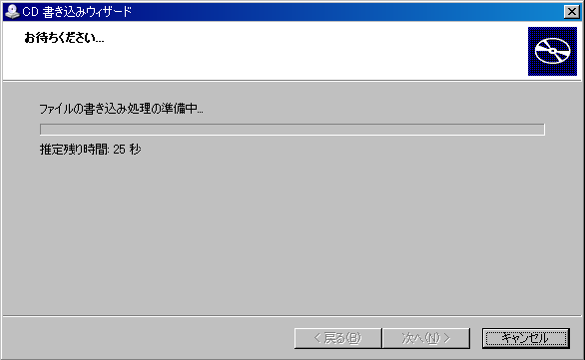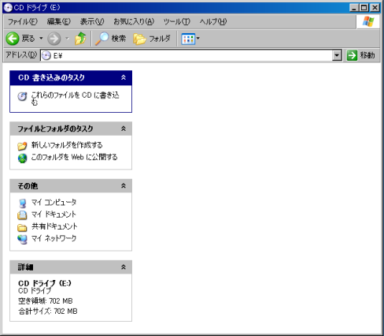

**(b)**

wait

**(a)**

**Finish**

1. Click (turn off electron beam) and change accelerate voltage to 10kV.

**For protection electron gun, wait for 3minutes until electron gun become cold. (use sand clock)**

1. Make sure that sample stage locates exchange position.

　X＝0 mm T＝0 °



　Y＝0 mm R＝任意

　Z＝15 mm

1. Rotate [MAGNIFICATION] tab and regulate magnification to minimum.
2. Push AIR/EVAC button. “LOW” lump light up and become atmosphere pressure in the analyzer (for about 1 minutes).



1. Pull sample stage slowly.
2. Remove your sample and set blank sample. **(Wear the latex glove.)**
3. After close sample stage slowly, push AIR/EVAC button with holding lightly against upper left of door and vacuate in the analyzer.

※Hold lightly against upper left of door until pump sound become small.

1. Make sure that vacuum bar change “red(low vacuum)”→”green(medium vacuum)”→

“blue(high vacuum)”

1. Finish “S-3000N”application.
2. Shut down Windows.
3. Switch off “DISPLAY” switch and “EVAC POWER” switch.

（Cooling water stop automatically after tens）

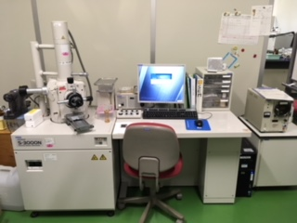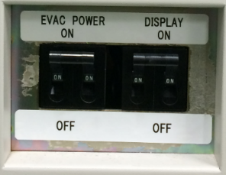

①

②

1. **Fill your name on register !!!**